Programming Fundamental Theory

Assignment #1

**Name**: Ali Zain

**Section**: BsCs1-M

**Nu**-**ID**: 21K4653

Problem #1

Start

Pick corn

Do

If new corn > corn

Then Pick new corn

Else

Then Keep corn

While He reached out of meadow

End

Problem #2:

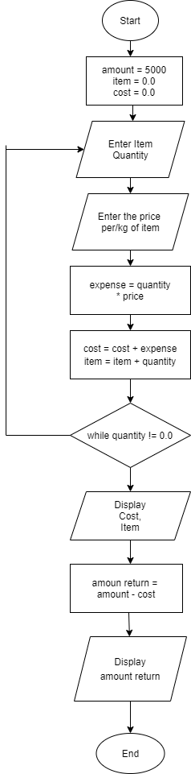

Problem #3:

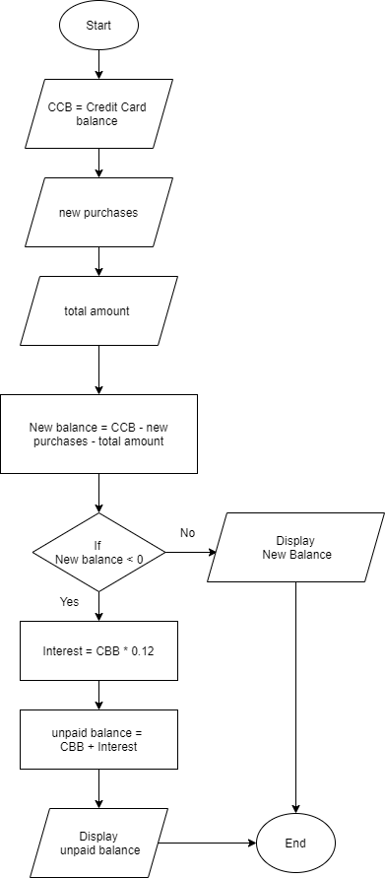

Problem #4:

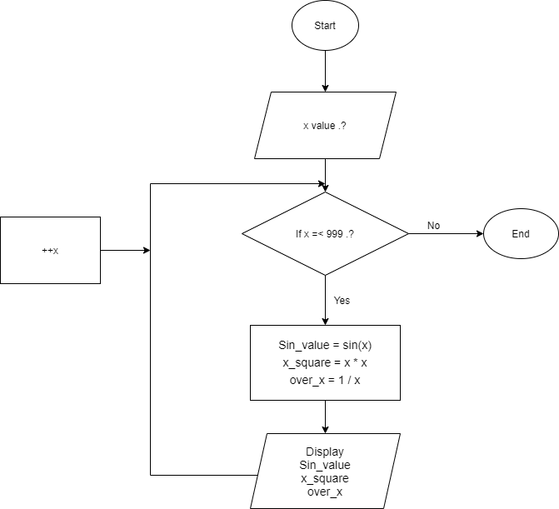

Problem #5:

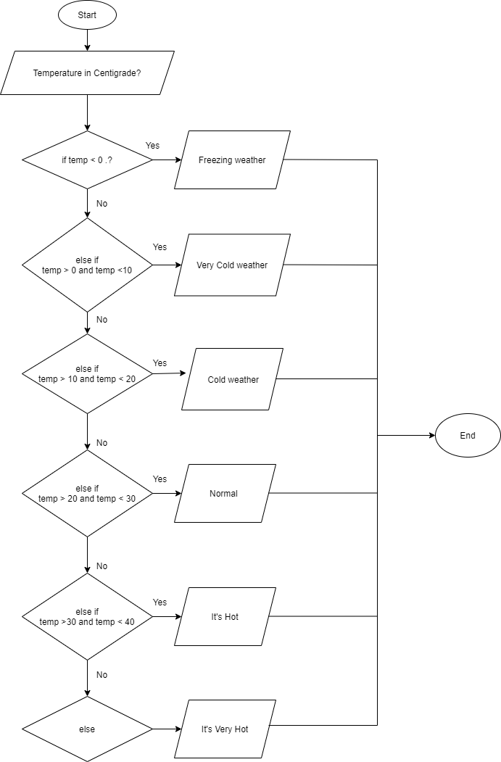

Problem #6:

PAC

|  |  |  |
| --- | --- | --- |
| Data | Processing | Output |
| Withdrawal amount | Enter Withdrawal amount |  |
| If  Withdrawal  amount% 20 != 0 | Display  “You must enter multiples  of twenty only “ |
| else  Amount = Withdrawal amount / 20 | Display  “Amount withdrawal is  Amount number of 20 dollars” |
| Repeat until  Withdrawal == -999 |  |

IPO Chart

|  |  |  |  |
| --- | --- | --- | --- |
| Input | Processing | Module | Output |
| Withdrawal  amount | Enter Withdrawal  amount | 0000 |  |
| If  Withdrawal  amount % 20 != 0 | 1000 | Display  “You must enter multiples of twenty only” |
| else  amount = Withdrawal  amount / 20 | 2000 | Display  “Amount withdrawal is amount number of 20 dollars” |
| Repeat untill  Withdrawal  Amount == -999 | 3000 |  |

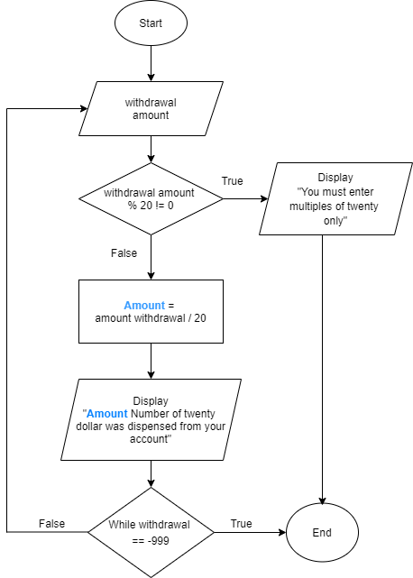

Problem #7:

Start

Set count = 0

Input list item

For item in list item

If item == tea

Then increment count by 1

Else if list is finished

Then Display count

Else

Then Iterate the number of time item in the list

End

Problem #8:

Start

Read Operator (o)

If o == ‘q’

then End

else

then read op1, op2

switch(o)

Case o == ‘+’

Output op1 + op2

Calculation Sum = op1 + op2

Calculation Sub = op2 – op1

If Sum > Sub

then Output “sum is greater”

else

then Output “sub is greater”

Break

Case o == ‘ - ‘

output op1 – op2

Calculation sub = op2 – op1

Calculation sum = op1 + op2

If Sum > Sub

then Output “sum is greater”

else

then Output “sub is greater”

Break

Case o == “*”

Output op1 * op2

Break

Case o == ‘/’

If op2 != 0

then Output op1/op2

else

then Output “Invalid Operation”

Break

Case (default)

Output “Invalid Operation”

Break

End